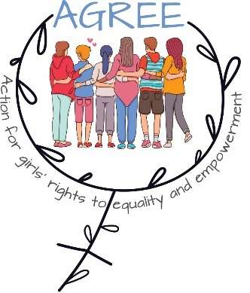
AGREE – ACTION FOR GIRLS' RIGHTS TO EQUALITY AND EMPOWERMENT!"
IPA III / 2024 / 459-906

Quality Evaluation Grid
To be completed by each member of the Selection Panel

TITLE OF THE PROJECT PROPOSAL
APPLICANT
THE SELECTION PANEL MEMBER
DATE
SIGNATURE

I. Relevance of the proposal (maximum 30 points)
Criterion | Points | Maximum
How relevant is the proposal to the objectives and priorities of the Call for Proposals, including integration of gender equality and inclusion perspectives? |  | 15
How relevant is the project proposal to the needs of your project target groups? |  | 15

II Quality of the proposal (maximum 40 points)

Are the activities proposed appropriate, practical, and consistent with the objectives and priorities of the Call? |  | 10
Are the activities feasible and consistent in relation to the expected results? |  | 10
Do the proposed activities ensure safe and inclusive participation of children and young people? |  | 5
Do the project activates promote and include directly girls? |  | 5
Is the action plan clear and feasible in relation to the timeframe? |  | 5
Level of creativity and innovation |  | 5

III. Operational capacity of the applicant (maximum 10 points)

Does the applicant have sufficient experience of project management? (at least one project completed) |  | 5
Does the applicant have sufficient thematic expertise? (especially knowledge of the issues to be addressed.) |  | 2
Has the applicant provided financial/narrative reports for the previous year? |  | 1
The level of dissemination activities showed |  | 2

IV. Budget and cost-effectiveness (maximum 15 points)

How realistic and effective the budget is in relation to the proposed action |  | 10
Are the activities appropriately reflected in the budget? |  | 5

V. Visibility
How adequate is the visibility in relation to the project? |  | 5

Total points |  | 100

A brief comment of the Selection panel member

