
AGREE – ACTION FOR GIRLS' RIGHTS TO EQUALITY AND EMPOWERMENT!"
IPA III / 2024 / 459-906

APPLICATION FORM

For Sub-granting Scheme
under the project “AGREE! – Action for Girls’ Rights to Equality and Empowerment”

Deadline for submission of applications: 18.09.2026 23:59 local time

Title of the action:
Type of the action | - One-off activity/event (maximum €5,000)  - Project (maximum €10,000; duration up to 6 months)
Location(s) of the action: | <specify country(ies), region(s), area(s) or town(s) that will benefit from the Action>
Name of the applicant
Nationality of the applicant
Date of establishment:
Official registration number

If you apply on behalf of others, please explain:

Applicant's contact details for the purpose of this action
Official address:
Telephone number: (fixed and mobile) Country code + city code + number
Legal Representative’s Name, Surname and Title
Name of the Contact person for this action:

Contact person's email:
Website of the Organisation:
Facebook
Instagram
LinkedIn
Other

Dossier No

AGREE partner to fill

Summary of the action

Please complete the table below which should not exceed 1/2 page.

Title of the action:
Location(s) of the action: - specify country(ies), region(s) that will benefit from the action
Total duration of the action (months): | <Starting date>  <End date>
Amount of requested | <Local currency >
Objectives of the action | <Overall objective(s)>  <Specific objective(s)>
Beneficiaries
Estimated results
Main activities

- Relevance of the action (max 2 pages)
  - . Relevance to the objectives/priorities of the call for proposals
Please provide all the following information:
    - Describe the relevance of the proposed action to the objective and priorities of the call for proposals, in particular concerning its thematic focus.

  - . Relevance to the particular needs and constraints of the target country/municipality

  - Describe and define the beneficiaries, their needs and constraints and how the action will address these needs

- Description of the action (max 3 page) Please provide all the following information:
- Describe the objectives of the action (elaborate here on the objectives mentioned in the table in Section 1.1 above).
- Provide a detailed description of the activities foreseen Specify related outputs and results.
- Provide information on potential partnerships and cooperation with other organisations/institutions (If you have a project envisaged cooperation with an institution or association specify how it will unfold)
- Describe how you will ensure safe and inclusive participation of children and young people.

- Describe how you will promote gender equality and directly involve girls
- Describe you monitoring and evaluation for the action
- Describe your plan for visibility of the action
- Provide the information about a) Duration and b) indicative action plan for implementing the action
- The action plan will be drawn up using the following format:

Activity | Month 1 | 2 | 3 | 4 | 5 | 6 | Implementing body
Example | example |  |  |  |  |  | Example
Preparation Activity 1 (title) |  |  |  |  |  |  | Applicant
Execution Activity 1 (title) |  |  |  |  |  |  | Partner
Preparation Activity 2 (title)
Execution Activity 2 (title)

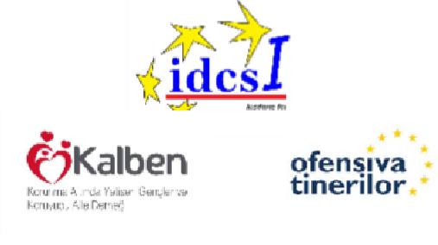
- Management of the project (Short description of at least two persons who will directly manage the project)

- IDENTITY OF THE APPLICANT

Legal data about the Applicant

Registration Number
VAT Number
Date of Registration
Place of Registration
Official address of Registration
Country of Registration / Nationality
Legal status
Name and the address of the Bank
Bank Account number

Capacity to manage and implement actions

Number of employees
Number of volunteers
Other resources (office, equipment…)
Experience in managing / implementation of the actions
Project 1
Title of project
Period of realization
Donor and amount
Most important results
Project 2
Title of project


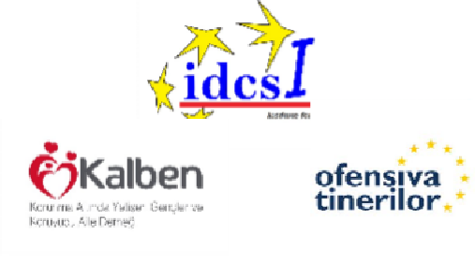

Period of realization
Donor and amount
Most important results
Project 3
Title of project
Period of realization
Donor and amount
Most important results


6

