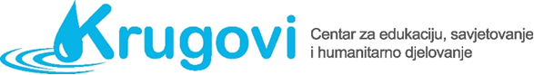

Additional information for the European solidarity corps project:
Included individual creates satisfied society

Where are we located in Zagreb?
Kombolova 13, Utrina, Novi Zagreb
- Work space, counselling space and Donation centre
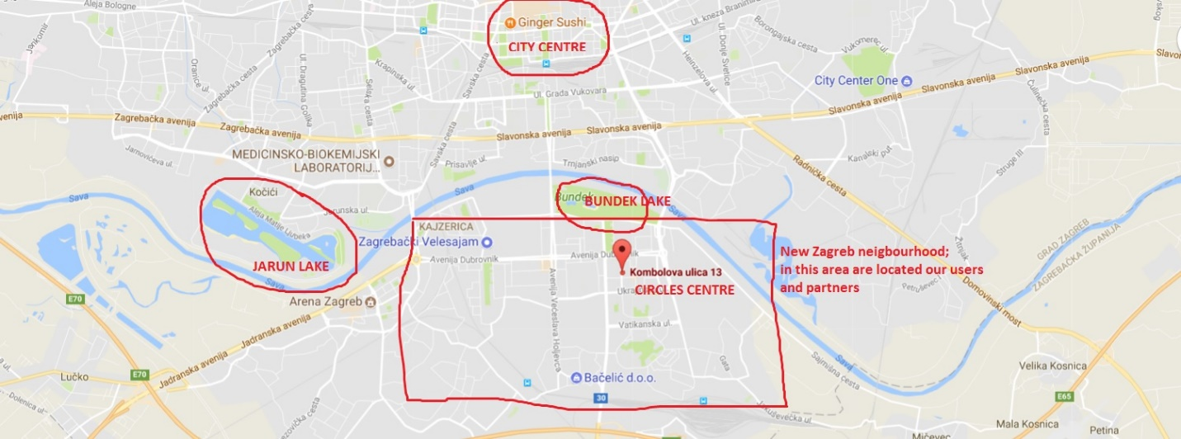

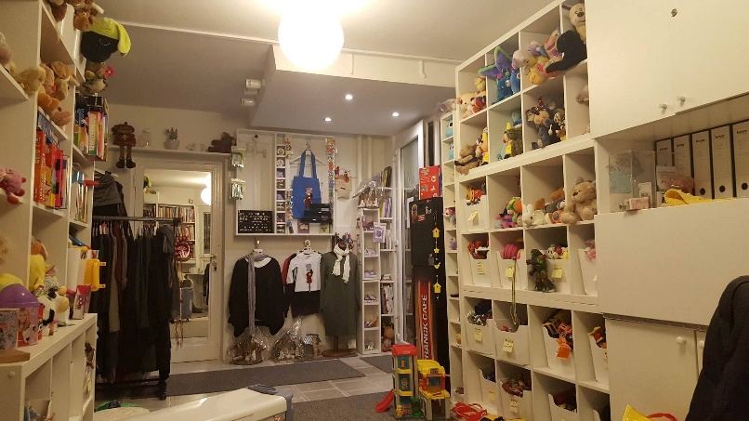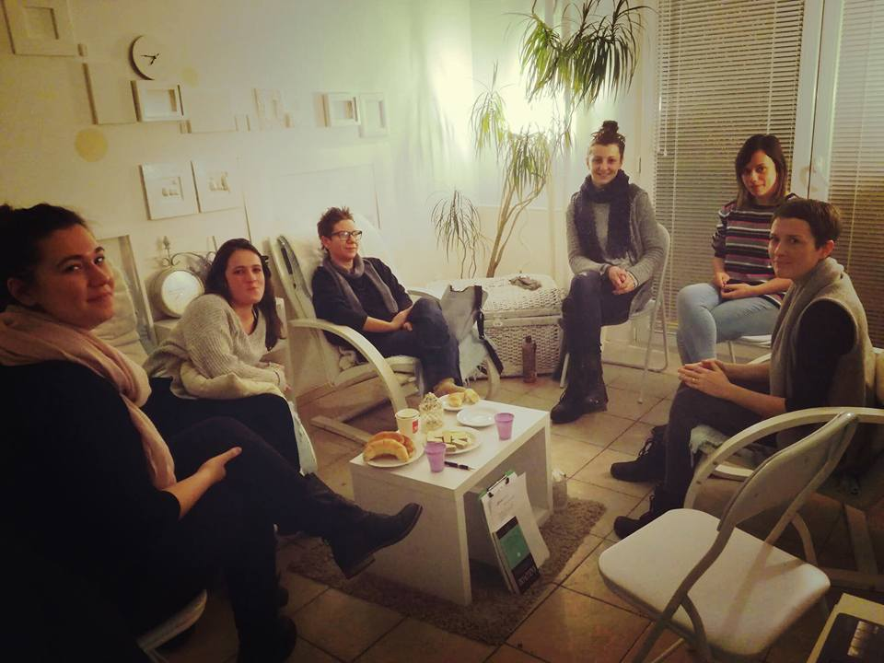

Project team of Circles Centre:
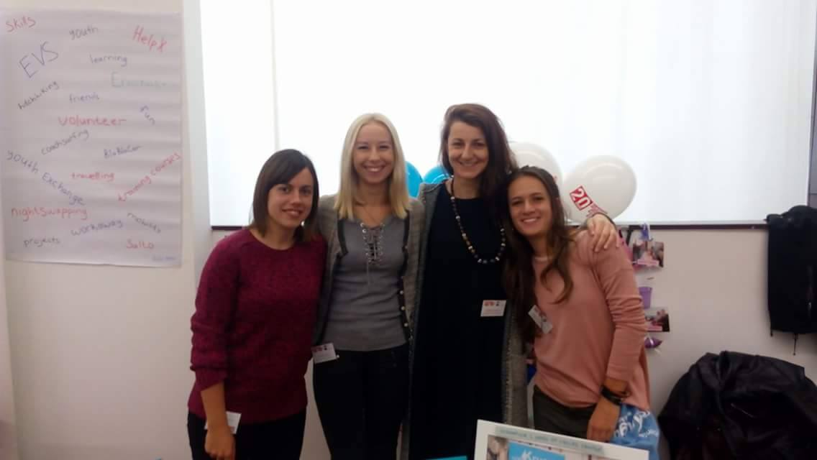
1 Ramona i Tihana ( u sredini )
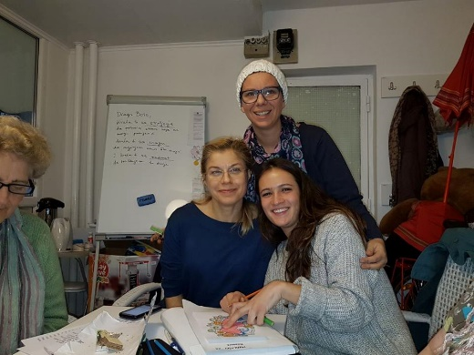
2 Jelena ( stoji ) i Antonija ( desno )
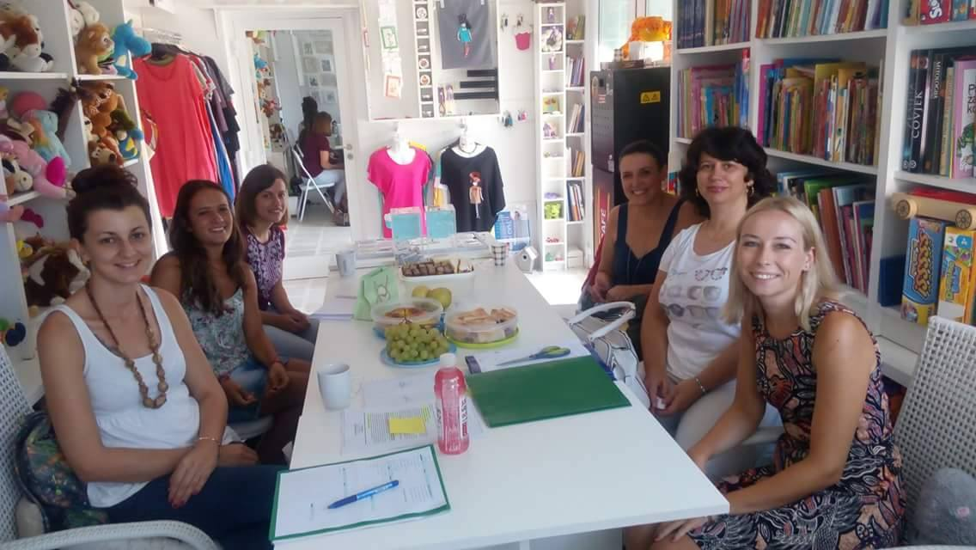
3 Ivana ( lijevo gore ) i Svjetlana ( lijevo u sredini )
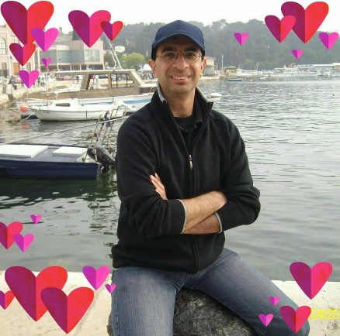
Mentors:
4 Imad
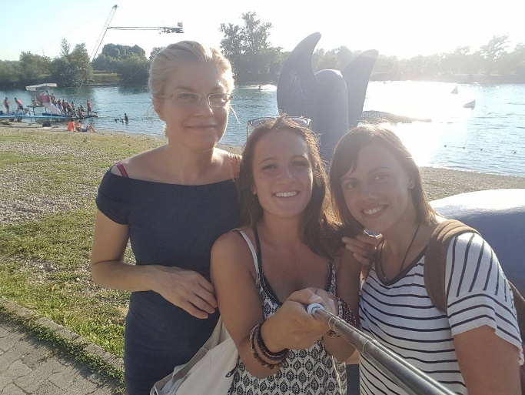
5 Antonija

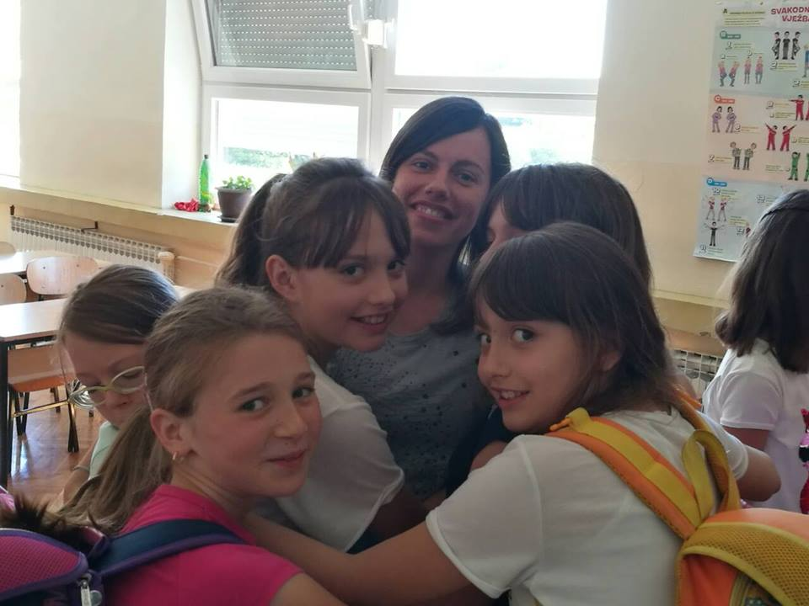
6 Adriana

Imad is from Iran, lives in Croatia, in Zagreb.
He speaks Croatian and English language. She has a three year mentoring experience in international volunteering projects. Support for volunteers in adapting to life in Zagreb.

Antonija is from Croatia, lives in Zagreb.
She speaks Croatian and English language. She has a three year mentoring experience in international volunteering projects. Support for volunteers in personal development and crisis situations.

Adriana is from Romania, lives in Croatia, in Zagreb.
She speaks Croatian, English, and Romanian language. Former EVS volunteer of Circles Centre.

Iva is from Croatia, lives in Zagreb.
She speaks Croatian and English language. She is volunteer in Circles Centre, support in learning English / Croatian language.

Language Support:

We provide language support (online language support + volunteer support in learning + educational materials).

Accommodation:

Circles Centre (within the budget of the project) provides accommodation - pay the rent of apartments and directives.
A secured apartment for 4 volunteers with a kitchen, bathroom, 2 bedrooms / take care of sharing your room with one of the participants - the same sex. The apartment is in Trnsko-Novi Zagreb neighborhood, near the Center Circles (Utrina, Novi Zagreb).
Please, if you have, bring your laptop for your own private use. We will provide laptops for work in Center and on activities. In the apartment and office you will have free WiFi.
Towels, bed linen, pillows, blankets, dishes, ... - we also provide.

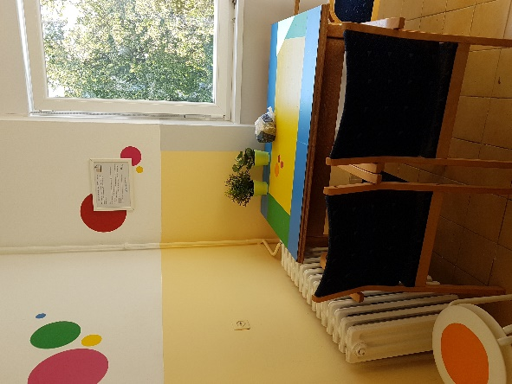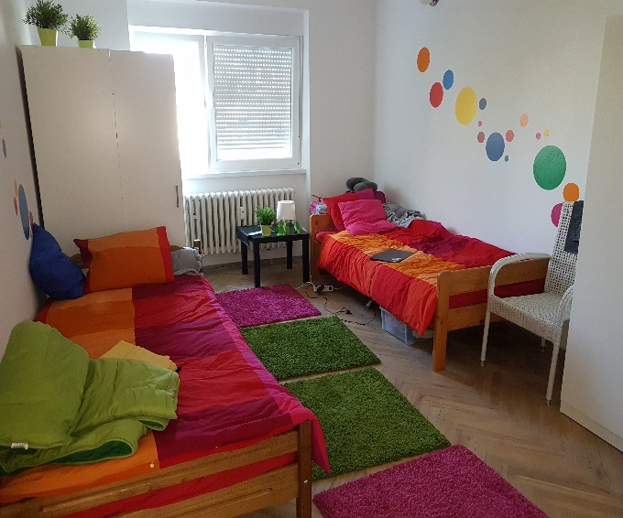
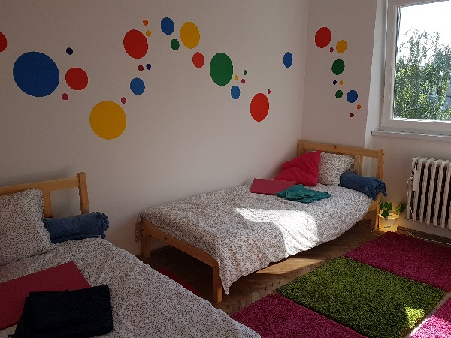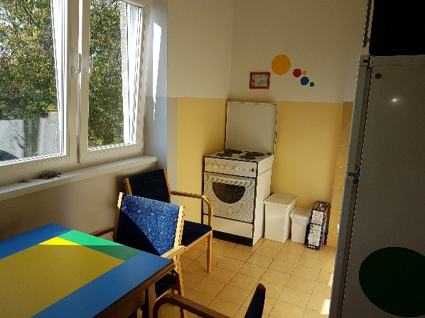

Transportation from your city to Zagreb:

We will help arrange transportation (bus, train, airplane), as well as cover travel costs.

Transportation in Zagreb:

We provide bicycles for transportation, as well as public transport tickets (tram, bus).
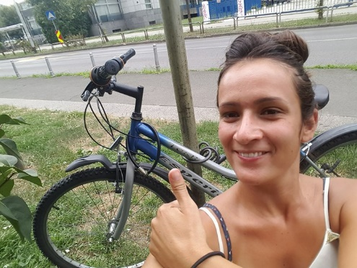

Food and pocket money:

They are insured through the project - monthly payout payments and food supplies.
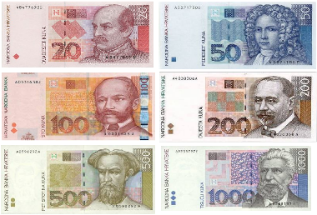
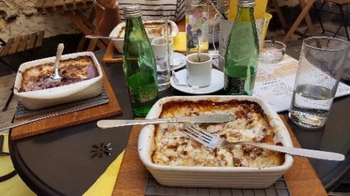
- Approximately 1,100 kn per month for a pocket money ( cca 150 euros )
- 50 kn per day for food - about 1,500 kn per month ( cca 204 euros )
- free accommodation (hire and rental), free of charge
- wifi, secured travel, secured work materials

Volunteer Schedule:

- 5 days a week, 6 hours of volunteering per day
- morning and afternoon shifts
- for work on weekends, a free day through a week
- self-arranging schedules with the support of coordinators and mentors
- free weekends, except during events or other events within the project association
- 2 additional free days per month
- vacation

Free time in Zagreb:
- opportunity for cultural-artistic events, sporting events, active nightlife

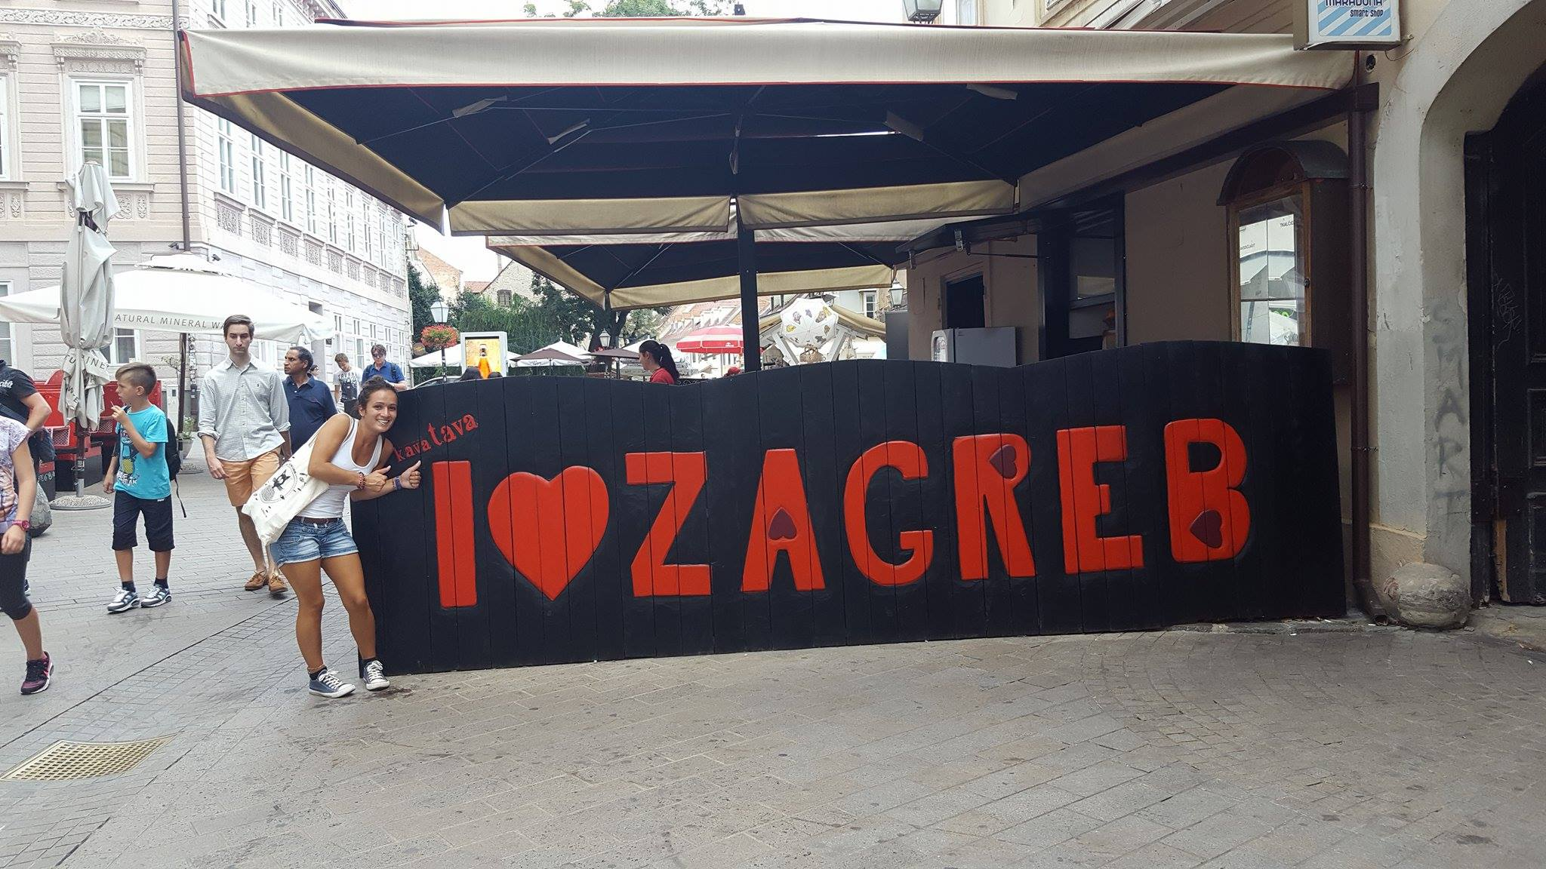

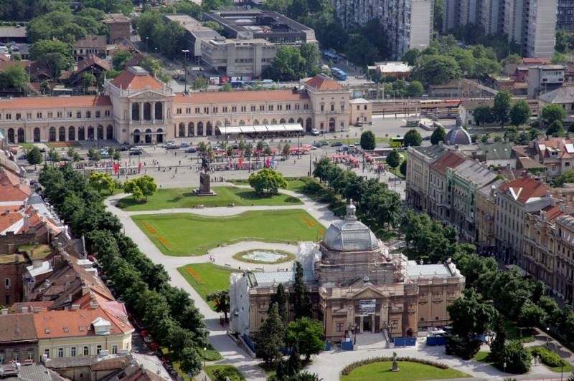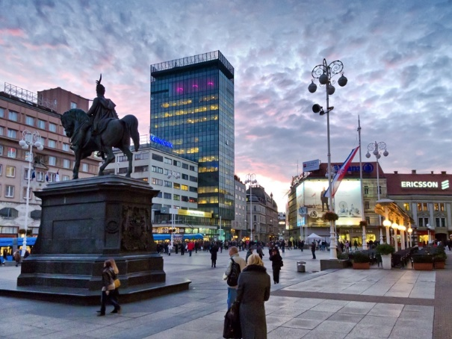

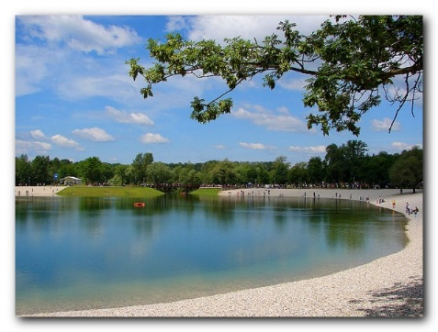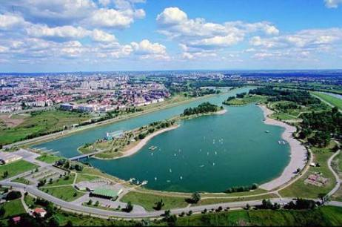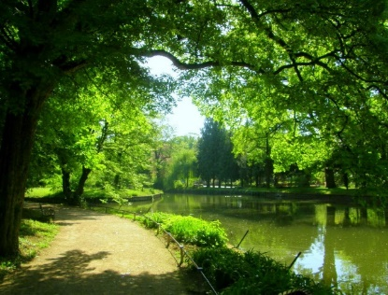
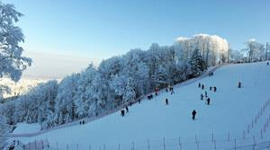
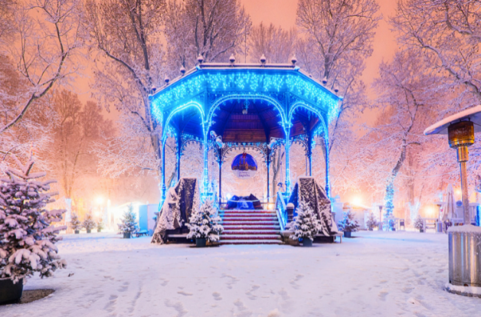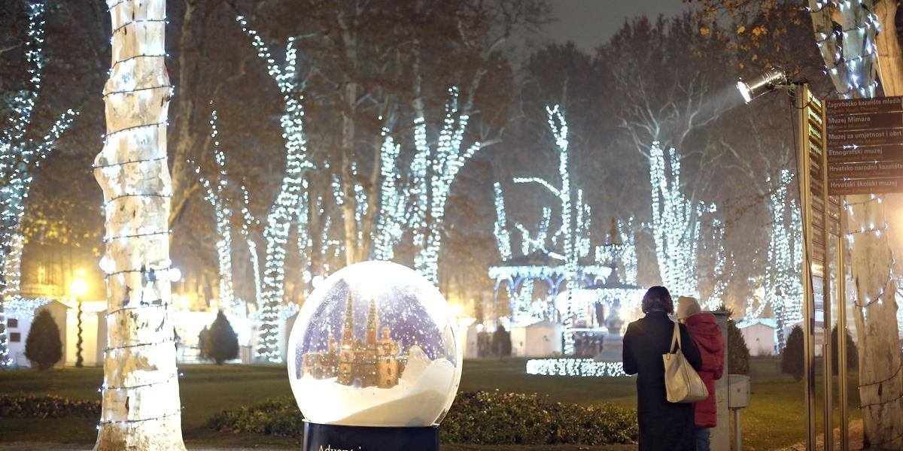
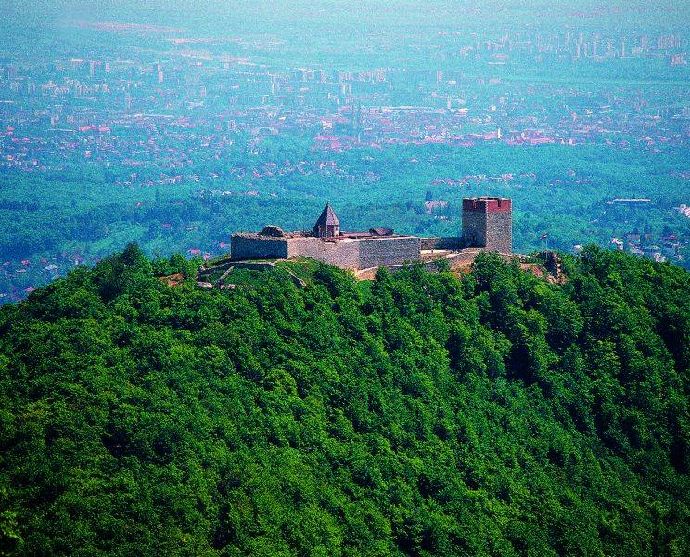

Free time outside of Zagreb:

- trips with other Croatian and international volunteers
- socializing with Croatian and international volunteers, other young people

