Welcome…

We are looking forward to see you from 24. – 31th May in Sarajevo, Bosnia and Herzegovina.

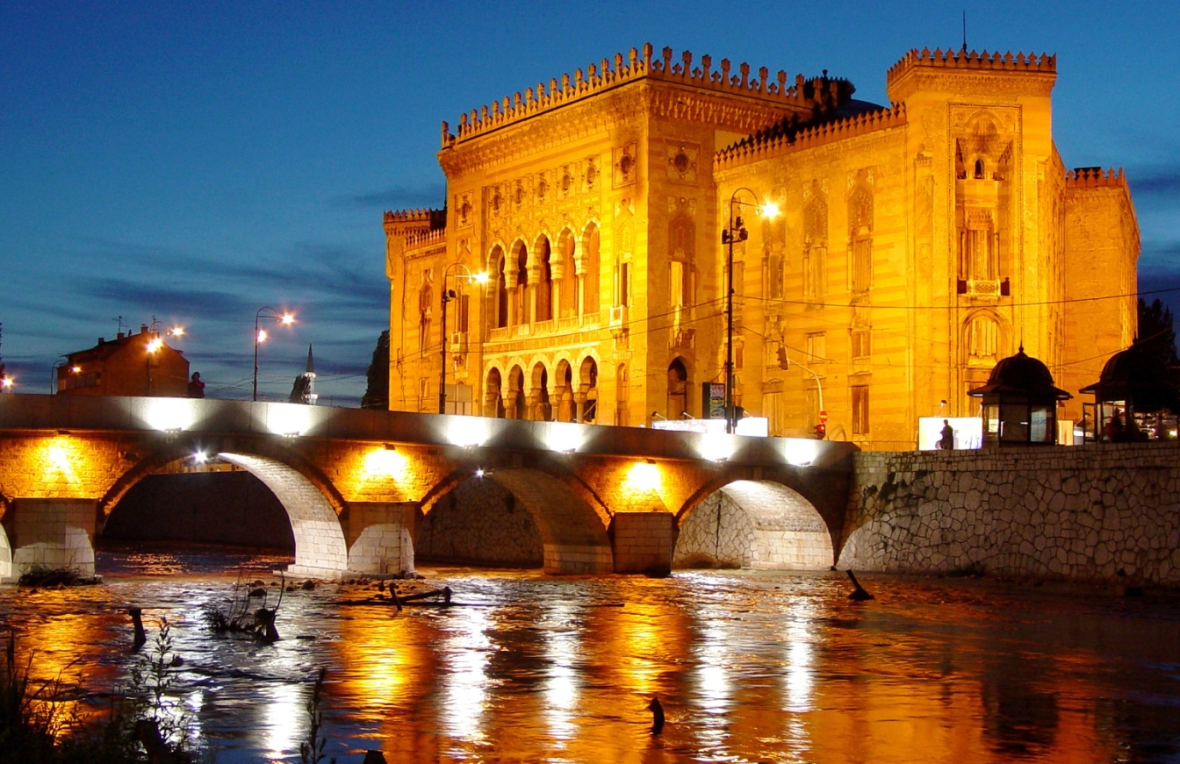

But before you come in the town of warm souls, there is still a lot to do. To make this project successful and in wish to help you, we prepared this information guide. Here you can find all important informations you need for your preparation.

Key Action 2,
Training Course – Campaing for Volunteering

„Volunteering connecting communities 2.0“

INFO ABOUT PROJECT:
Volunteering connecting communities 2.0 (VCC 2) is a continuous cooperation of the project Volunteering Connecting Communities enriched with an upgraded approach and offering several valuable tools that shall be used in the local level. This is a project which involve 500 youth workers, 5 organizations, 15 schools and over 2500 young people (members/activists/young people of whole consortium) to get empowered through information and concrete tools in volunteerism and inclusion topic in local and international level. All partners will get equally involved and share responsibilities and tasks in series of activities planned in local and international level regarding preparation, implementation and dissemination of the results. This project aims at increasing youth potential in civic education and especially volunteerism topic through capacity building actions targeting youth workers who work with young people with fewer opportunities in local and European level. The project aims as well to increase the quality of youth work through exchanging of experiences and building up sustainable partnership among partners of the consortium and other NGO-s and institutions in respective countries.
The activities of the project will consist on different Meetings, info sessions, seminars, training. In international projects, the methodology of the project will be mainly based in non formal education approach. Concrete methods to be used are: brainstorming, role plays, simulation exercises, debate, open group discussion, questions and answers, theatre, buzz groups, presentation of short videos, collage, creative workshops etc.

Project’s overall Aim is: Support for social engagement of young people, youth workers and youth organisations through volunteering and capacity building actions with direct impact to boost active citizenship, inclusion, cross sectoral cooperation and quality of youth work in the local communities.

Objectives:
- To build capacities of partner CSOs working with young people with fewer opportunities, their beneficiaries and volunteers on volunteering and its qualitative management;
- To develop further and support existing local volunteering infrastructures (volunteers Hubs) through cross sectorial approach;
- To plan and implement awareness raising campaign on promotion and values of volunteer work in local communities;
- To share best practices, exchange “know how” and establishing bridges of closer cooperation with various stakeholders.

Activity 2. 24.-31 May 2021, Sarajevo, B&H. Seminar on different tool which can be used for promotion of Volunteerism

INFO ABOUT ACTIVITY:

The firsth activity within this project is a seminar that will be held in Sarajevo for a period of eith days. The seminar will be attended by 20 participants.

This training is aiming to train 20 youth workers how to develop campaign in local community using online and offline tools. Each partner will send 4 representatives and participants of this activity will be those who will implement the local campaign in each country and act as multipliers.

REIMBURSEMENT:

Reimbursement limits per country, we will receive a certain amount of money for this purpose, by regarding Erasmus+ Program rules we need to follow certain administrative procedures.
Save your original tickets and receipts, invoices and all related documents, because you can only get reimbursement for costs of which you can prove the amounts with original tickets and receipts. Only the amount written on the ticket will be reimburse.

COUNTRY | NAME OF ORGANIZATION | NUMBER OF PARTICIPANTS | TRAVEL COST (EUR)
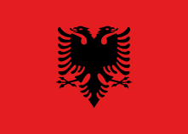Albania | BBA | 4 youth workers | 180 per participant,
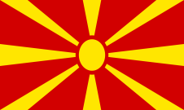  Macedonia | VCS | 5 youth workers | 180 per participant,
Romania | Asociatia Allons-y | 5 youth workers | 180 per participant,
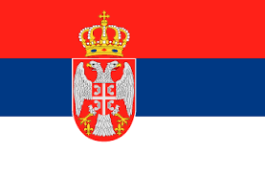  Serbia | IUVENTA | 5 youth workers | 180 per participant,

WHAT TO BRING?

-Ideas, motivation and smile ;
-Warm clothes (it may rain and windy);
-Sunglasses (it may sunny);
-Personal medication;
-Bring something what represents your country for intercultural nights. Food, drinks, music, dance and material to represent country you are coming from;
-Don't forget to bring informations about your organizations.

ACCOMODATION:

- Arrival day is the 24 May and departure day is the 31 May.
- Accommodation will be located in “Braca Mujic'' hotel- Sarajevo (http://hotelibm.com/hbm/)

- All participants will be accommodated in shared bedrooms (2, 3). In the room there is a toilet, bathroom, TV, towel, hair-dryer and air-conditioner .
- Please bring your own Slipper/sandal and there is free wifi-connection on the venue.

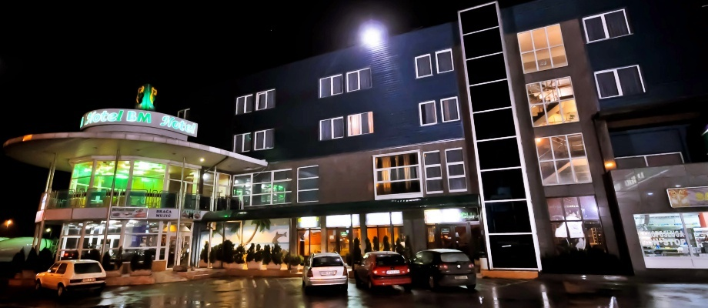
TRANSPORTATION:
We will organize transportation from airport, train and bus station.
Before your trip, or during the trip, you have to contact us, and let us know in what time you will come here, so that we can organize transportation.
DIRECTOR:
Belmin Debelac
Email: belmin.debelac@gmail.com
Phone: +38761757604
Most important!
The activity will be held under restriction measures (usage of masks, distance etc) to ensure the safety of all participants.

EMERGENCY PHONE NUMBERS
Police: 112
Fire department: 123
Ambulance: 124

