Volunteering connecting communities / VCC

Please note: Due to situation cased by Covid 19, the training will be implemented under strict measures taken by the organizers. The organizers will provide disinfectant solution and masks for all the participants every day. The training will be conducted in two big meeting rooms and the distances will be respected. We invite all the participants to respect the measures and cooperate for a safety environment for all the attendees.

Activity 4: TC on structured volunteerism, training youth workers in volunteer management cycle
02-11 October 2020, Durres, Albania
The training course aims to support the professional development of youth workers and youth leaders who work in inclusion on their critical understanding of volunteerism and active youth participation for being active citizens in each local community. It explores and makes participants experience its potential by enabling them to recognize and integrate structured volunteerism and other forms of youth participation in their youth work. The training will improve the competencies of youth workers about how to work with structured volunteerism technique and its elements. Beside this, training will offer information for opportunities and programmes offered by EC and other donor in order to empower young people to take action in every day work. As a result of the course, a PDF module will be produced to be used as a resource material in local volunteer structures created during the project. The module will describe the concept of “structured volunteerism technique”, how to develop it and how to work with it in daily bases.

PARTICIPANT PROFILE :

- Eligible participants should be youth workers, youth leaders in partner organizations, resident in respective partner countries
- be aged between 18 and 35 years and be gender balanced
- be able to work in English
- be available and fully committed to take part in the training
- be curious, open-minded, appreciate diversity and learn about each other’s realities.
- be motivated to learn and to apply the principles and approaches of the training, notably volunteering, active citizenship, and intercultural dialogue

Arrival date and time: 02/10/2020, latest at 16:00 o’clock in the hotel.
Departure from the hotel is on 11.10.2020, latest till 11:00 o’clock
IMPORTANT NOTICE!
If you are arriving earlier or leaving later from the training dates, you have to take care of the accommodation by yourself on your costs. If you organize your flight out of the training dates,
please contact us in advance.

VENUE AND ACCOMODATION
The activity will be hosted at the premises of Albanian Star Hotel, in Golem-Durrës Albania. The hotel is situated 39 KM from Tirana International Airport, on the coast of the Adriatic Sea, just in front of the seaside. Check for AS Hotel in their website: http://www.harmonia-hotels.com/
AS Hotel offers a 4-star quality service. You will be accommodated with 2 persons in rooms.
The rooms will be separated for males and females. You will need to bring your own shampoo, soap, tooth brush and tooth paste, and any other personal hygiene items you need.
The place has all the necessary facilities for developing a qualitative project and making your stay comfortable.
Three meals per day and 2 coffee breaks will be served in the ground floor of the hotel, respecting your dietary needs and making sure you receive freshly cooked food.
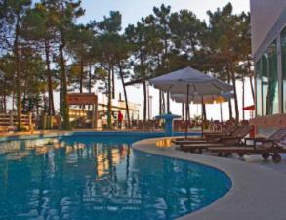 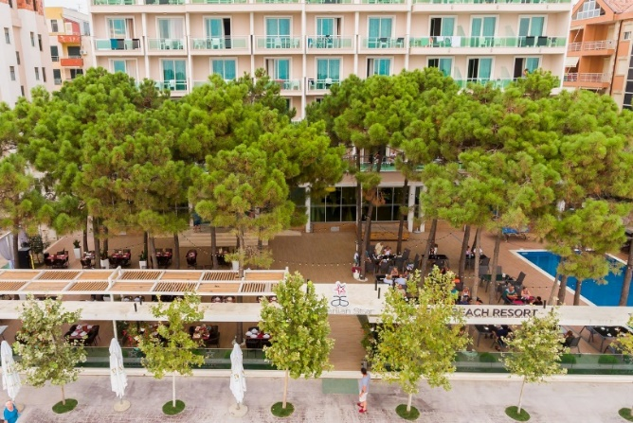
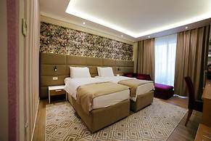

HOW TO REACH THE HOTEL
Local transport from Tirana Airport, Tirana bus station to the Hotel in Durrës and back will be organized from the staff of the hosting organization (Beyond Barriers). Please let us know as soon as possible about your flight so we can arrange your travel to the venue.
If you are coming to Durrës by bus, you will need to stop in Durrës main Bus Station which is in city center. From there, either we can arrange to pick you up (approx. 8 Euro per taxi) or you can get the local bus, with direction Plepa-Golem and ask the driver to stop you at “AS HOTEL", Rruga e Plazhit). The bus stop is in front of gas station, and from there is about 50 meters walk to the hotel. Local bus goes every 30 minutes and it cost 60 Lek.
What should you prepare in advance?

- Please prepare a short description of your work in your NGO, some of its projects, main areas of work in English to present them the other participants. Bring with you any type of promotional materials that you would like to show.
- Bring cameras, your personal computer (if you have) so we can work on multimedia tools on promotion of volunteering.
- An intercultural evening will take place (check the program). Please bring some typical food, drink, national specialties, songs, instruments, brochures etc. to present your culture to the rest of the group.
- Good mood and enthusiasm and your mask as well

HOW TO APPLY
You are requested to use the application from attached.
Please complete your application in English .
please submit your application to :
anadervishi@gmail.com

The deadline for sending the application forms is 20th September 2020.
CONTACT
Silvia:
00355 69 95 62729

TRAVEL COST AND REIMBURSMENT :

- Please take in consideration that your flight tickets can be up to 1 day before start of the program and also maximum 1 day after the end of the program.
- It has to be a return ticket, we will not reimburse anything if you have only one way ticket.
- Participants are only allowed to travel to/from partner organisation countries (e.g. Serbian partners from Serbia, Romania from Romania etc.)
- The reimbursement will be cash during the activity based in respective invoices. For those who prefer a bank transfer we will send it after the training activity. If you buy the ticket to a travel agency, we need an invoice issued by the agency. If you by the ticket on line, please send us the bank statement as well.
- The leading applicant will only reimburse travel costs from the partner country to Durres, Albania up to the limits indicated in the Erasmus+ Programme Guide (see below), based on actual expenditure - original tickets and receipts; please note that amounts below are MAXIMUM amounts per person.
1 | Udruzenje "Mladi Volonteri" | Visoko | Durres | 180
2 | Iuventa | Sabac | Durres | 180
3 | PERTEJ BARRIERAVE | Tirana | Durres | 20
4 | VCS | Skopje | Durres | 180
4 | Association Allons-y | Craiova | Durres | 180

USEFUL INFORMATION
At present 1 Euro is equivalent to 123 ALL (Albanian Lek), according to National Bank of Albania.
If you arrive at Tirana Airport, we advise YOU to exchange your currency there.

IF you come by CAR
you can either exchange the money on the way in any of the Exchange Offices (Western Union, Zyre
Kembimi, etc.) which will not charge you a fee. If you go in a Bank, you will pay a fee, will need your
passport or ID, and spend much more time waiting.

If you come by BUSS then you will also be able to exchange the Euro into ALL in the Reception of the Hotel upon request. At the HOTEL you can also pay by EURO on a unified rate, used for businesses in Albania, which might slowly differ from daily rate.

NOT everywhere they accept EURO, so be advised to exchange your currency before.
IIMPORTANT:

You CANNOT exchange RSD, MKD, KM in Albania therefore be aware that your currency
should be EURO.

What to visit in DURRES
If you have some spare time and would like to visit Durres city Centre, we can suggest the following
attractions.
More info here http://albania.al/destination/15/durresi/

Durres Amphitheatre
The Archeological Museum
Ethnographic Museum
The seaside promenade called “sphinx”

THANK YOU AND LOOKING FORWARD TO WELCOME YOU ALL!
BBA TEAM!

CONTACTS
Ana – anadervishi@gmail.com
Phone number: 00355 69 95 62729

